# Lab 4 - Creating YARN Queues

## ​Create and Configure YARN Capacity Scheduler Queues

Capacity Scheduler queues can be used to allocate cluster resources among users and groups. These settings can be accessed from Ambari > YARN > Configs > Scheduler, which provides a graphical UI to edit the configuration file: conf/capacity-scheduler.xml.

1. Go to Ambari UI.
2. Click on YARN in the Application bar on the left
3. Select Configs at the top: 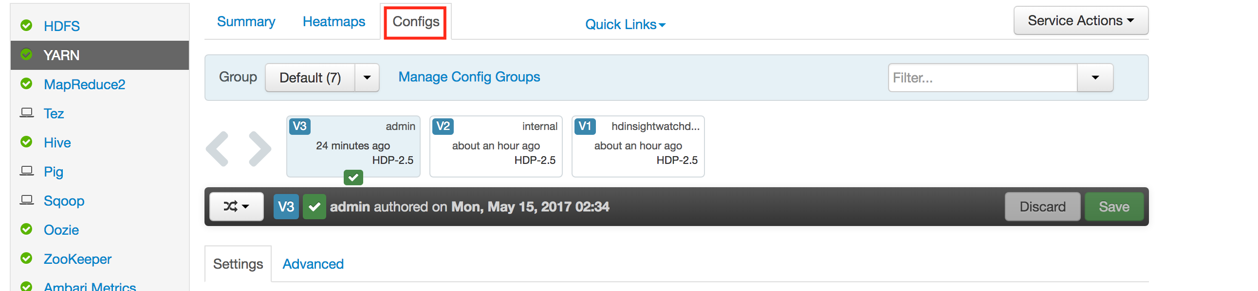
4. Click Advanced
5. Scroll down to scheduler: 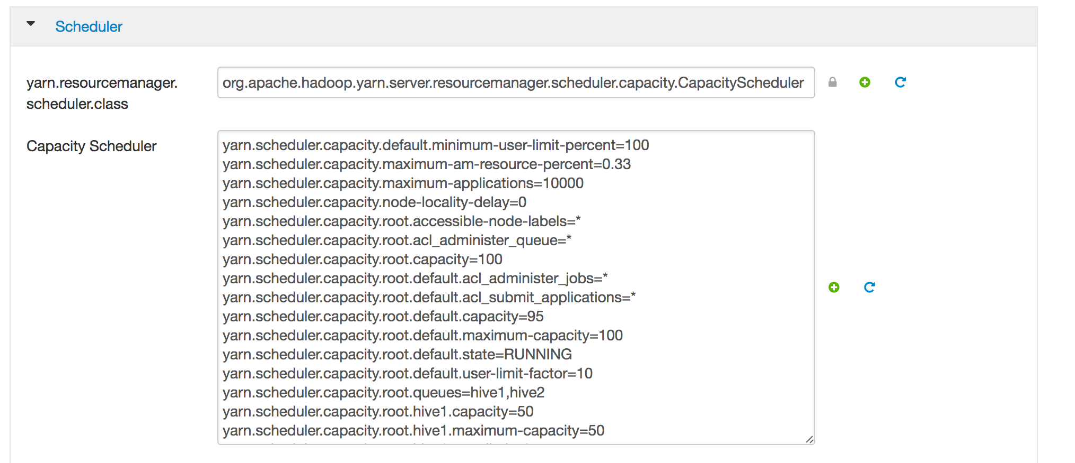
6. Edit with the following configurations hive1--This queue is used for short-duration queries and is assigned 50% of cluster resources. hive2--This queue is used for longer-duration queries and is assigned 50% of cluster resources. The following capacity-scheduler.xml settings are used to implement this configuration:

* yarn.scheduler.capacity.root.queues=hive1,hive2  
  yarn.scheduler.capacity.root.hive1.capacity=50  
  yarn.scheduler.capacity.root.hive2.capacity=50
* Configure usage limits for these queues and their users with the following settings:
* yarn.scheduler.capacity.root.hive1.maximum-capacity=50  
  yarn.scheduler.capacity.root.hive2.maximum-capacity=50  
  yarn.scheduler.capacity.root.hive1.user-limit=1  
  yarn.scheduler.capacity.root.hive2.user-limit=1

1. Edit these changes and save in YARN Configs. Click confirm.
2. Restart all affected services. 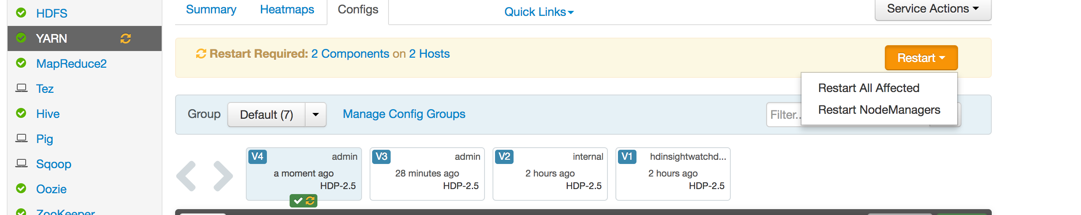
3. Check Queues in YARN Queue Manager View: 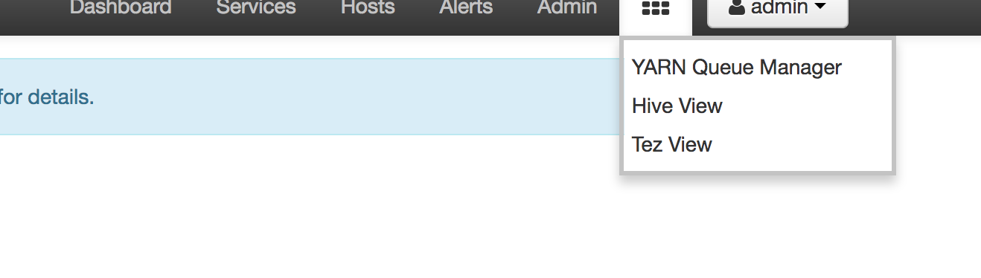
4. Re-run the last labs with the following setting before each query: set mapreduce.job.queuename=hive1;